**Potential Factors Affecting Movie Rating**

Question 1

*Is the movie release year related to movie rating?*

**The year a movie was released is unrelated to the average rating.**

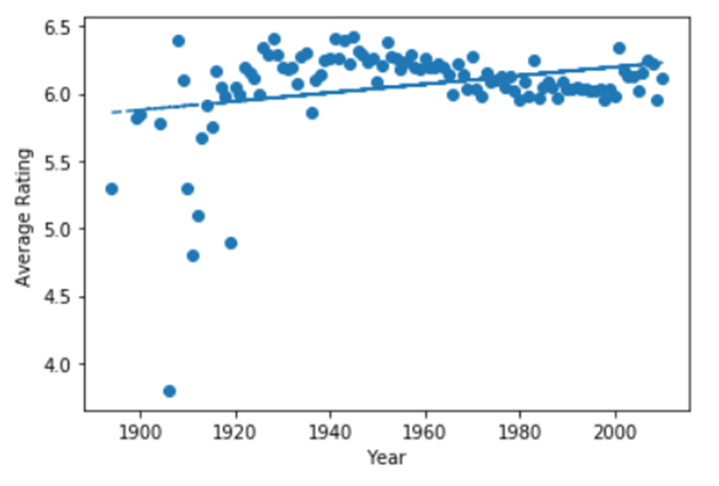

Question 2

*Is movie genre related to movie rating?*

**In general, genre is unrelated to movie rating. However, Documentary, Drama, and Comedy were consistently the top-rated movie genres, respectively, in each time period examined.**

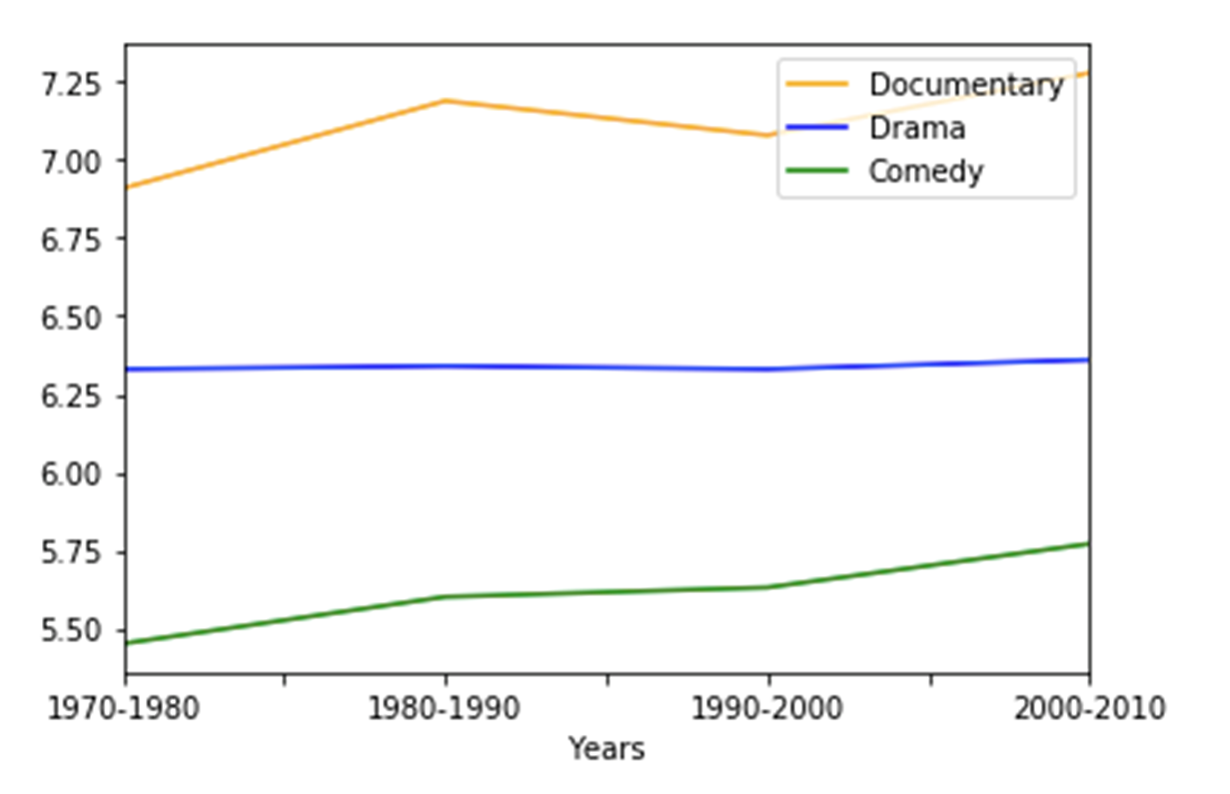

Question 3

*Is the number of votes related to movie rating?*

**The number of votes per movie is unrelated to the rating of the movie.**

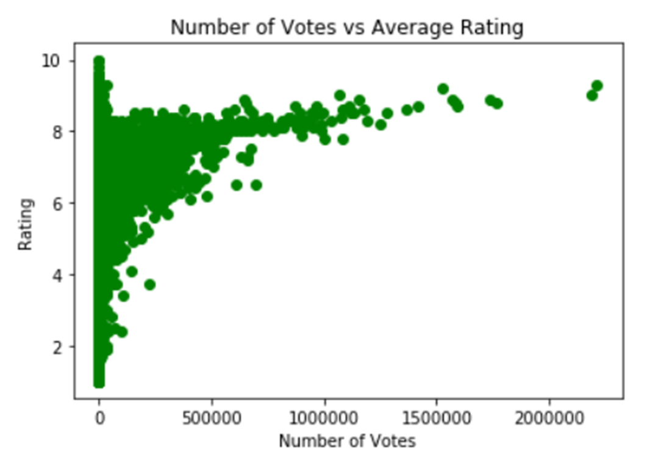

Question 4

*Is movie run time related to movie rating?*

**Movie run time is unrelated to the rating of the movie.**

